Humans, Animals and Society
Name
Name of the instructor
Course name
Date

Poster Presentation
Uses
Perceptions in the UK
- They are too sensitive.
- They die frequently.
- They get stressed easily.
Perceptions in the USA
- Guinea pigs are sociable.
- They crowd to form small groups for:
- Warmth.
- Possibly security.
- They prefer living in small groups.
- When in large population, they divide themselves into small subgroups to assist in reducing local densities.
Poster Presentation

Uses of Guinea Pigs
Kept as pets. 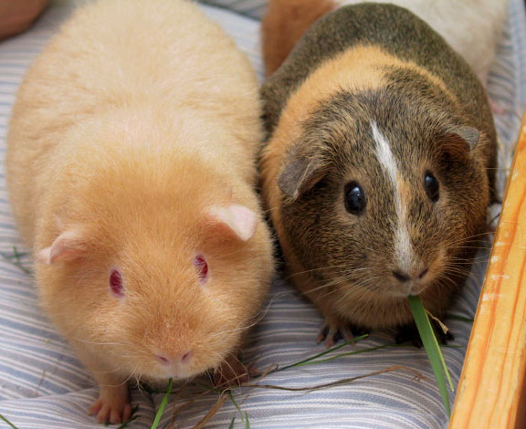
For meat.
For medical research.
In the study of immune, nervous and respiratory system.

Article
Use of Guinea Pig in Research and Medicine
For over 200 years the Guinea pig has been used in the research and medicine field. The guinea pig has been used in research and for medical purposes due to its commercial availability and gentle temperament. However, the use of guinea pigs in research has currently declined. For example in 2013, around 191,000 guinea pigs were utilized for research purposes. In 1985, 599,000 guinea pigs were used in research. Comparing the number of guinea pigs that were used in 1985 and 2013, it is clear that there has been a decline in the use of guinea pigs in research. Consequently, the scientists have also decreased the number of publications that they have been producing. In the 1980s, scientists were publishing around 3500 publications per year compared to less than 1000 produced in 2011.
The guinea pig resembles human beings, for example, they have some immunological responses that are close to human beings. This makes them be used in medical research where the scientists look for ways through which they could improve the field of medicine. However, in recent years, the use of the guinea pig has been overshadowed by the use of some other rodents such as mice and rats. These rodents have been genetically modified and are subject to fewer regulations around the United States of America.
The guinea pig was the first animal to be used in medical research. It has been used by medical researchers in various studies such as pharmacology, otology, nutrition, infectious diseases, immunology, gnotobiotics, genetics, delayed hypersensitivity, asthma, and anaphylaxis. An example use of the guinea pigs in pharmaceutical studies is that they have been used for preclinical testing of cardiac safety of new drugs. Additionally, the hairless guinea pigs have been used in the process of development as well as the testing process of topical drug preparations. They have also been used in the testing for sensitivity testing in the medical device sector. Since they resemble human beings in various ways, their serum has been used in many laboratories in the process of striving to come up with a conclusion regarding the diagnosis of the infectious disease.
The guinea pigs present a challenge during the medical research processes that might require the scientists to obtain blood. Their lack of a tail as well as the thick skin makes it hard to obtain blood compared to mice and rats. In case, a researcher wants to collect a few drops of blood it is easy to do so by cephalic venipuncture, saphenous, or jugular. in the case that a researcher needs to collect more than just a few drops of blood, then the procedure requires anesthesia such as terminal technique puncture, cranial vena cava puncture, or retro-orbital bleeding.
Assessment
Selecting an Animal for an Animal-Assisted Interaction Program
In recent years, animal-assisted interactions have evolved and are not alike. This makes the process of choosing one animal over the other for an animal-assisted interaction program, not an easy task. It is now vital for the researchers to go beyond training methods as well as not just choosing an approach that was developed many years back (Zeligs, 2014). Normally animal-assisted interactions go beyond just offering the participant opportunities to interact with the animals. The animals that are picked to take part in this process ought to have the capacity to motivate the participants in a way that engages them in a broad range of educational, communication, psychosocial, cognitive, and physical applications.

Training Methods
Sometimes it proves not to be an easy task to train an animal. This is so specifically when the animal shuts down when the animal handler tries to initiate a training session. The animal handler might result in holding a negative perception that he or she lacks what is required to be an animal handler (Melfi, Dorey, & Ward, 2020). Some of the methods that used to train animal are as discussed below:
Reward and Correction Training
Reward and correction training has been said to be one of the most effective ways of training animals. Most of the training manuals for animals such as a dog, normally recommend a reward and correction training method. They recommend this training approach due to its effectiveness. The method provides both the animal handler and the animal a chance to establish and develop a close relationship with each other (Melfi, et al., 2020). In most cases, an animal handler should strive to establish predictability as well as control over the animal. This is the reason that makes the animal handlers shout at the animals if they have failed to respond. Shouting at the animals makes the animals respond to certain commands.
Positive Training
Positive training is another method of training that has proved to be positive and effective. In positive training, the animal handler results in introducing a condition or a stimulus that tends to increase the likelihood of occurrence of the desired behavior (Melfi, et al., 2020).
Demonstration
If a kitty happens to be clawing table clothes, the animal handler can make it stop. This can be realized by taking the kitty to an empty room whenever it claws a table cloth. The kitty will, later on, come to realize that whenever it claws on things it is taken away and this makes it get isolated or is kept away from getting fun. The kitty will then stop clawing on the table cloth.
A guinea pig can be trained to respond when it is called by name. At first, the guinea pig can be placed on a surface but not so much far from the animal trainer. The animal trainer will place the guinea pig’s favorite treats in his hands and then call its name out and ensure that the treat is visible to the animal. This will be carried out daily until it gets used to it or it starts to respond when called out by name. This could be useful when doing medical research on a particular guinea pig.

References
Fine, A. H. (2011). Handbook on Animal-Assisted Therapy: Theoretical Foundations and Guidelines for Practice. Burlington: Elsevier Science.
Melfi, V., Dorey, N. R., & Ward, S. J. (2020). Zoo animal learning and training.
Micozzi, M. S., Koop, C. E., & Lundberg, G. D. (2019). Fundamentals of complementary and alternative medicine.
Zeligs, J. A. (2014). Animal training 101: The complete and practical guide to the art and science of behavior modification. Minneapolis, MN: Mill City.

